Snapshot Day 10/12/17 Data
(Salt Front Hudson RM 65)
RIVER MILE East RM 4.9
Sarah Pidgeon - SOLAR ONE
Katie Jungers, The Clinton School, 35 eleventh grade students
Location: Solar One, The East River at 23rd St.
Area: Beach area
Surrounding Land Use: Stuyvesant Cove Park
Sampling Site: Recreational pier – rocks near the edge, banks altered
Depth: 8 feet at high tide
Plants in area: Native Plants
Sampled from 10am to 1PM
Surrounding Land Use | 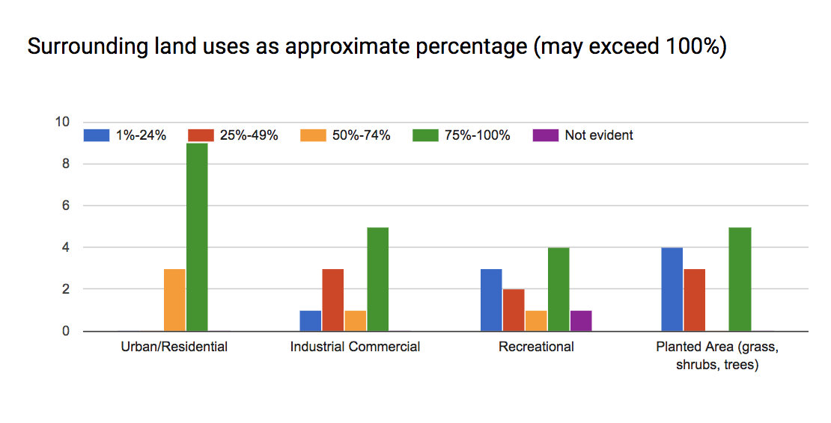
Air Temperature  Average ~17.3 C | 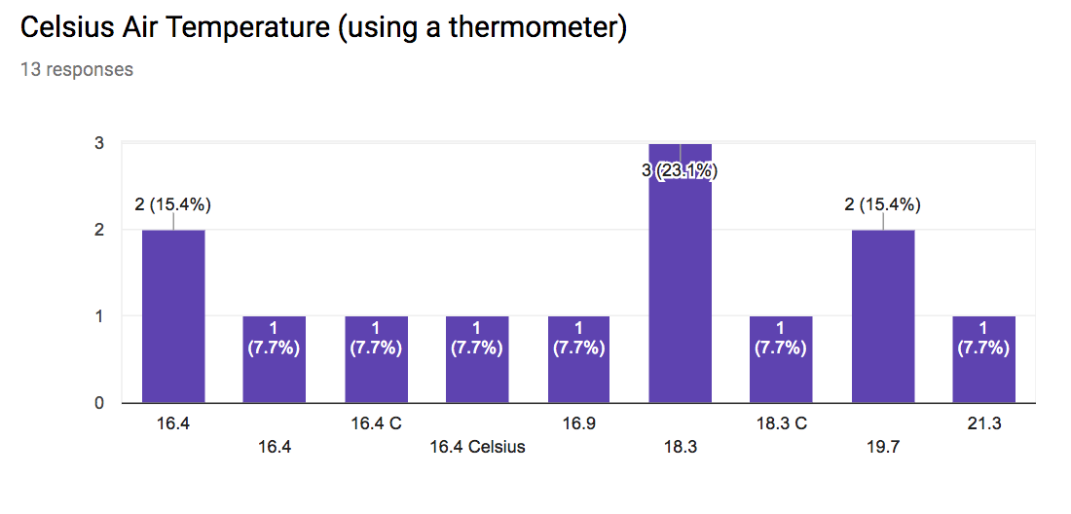
Anemometer Wind Speed – 3.2 mph | 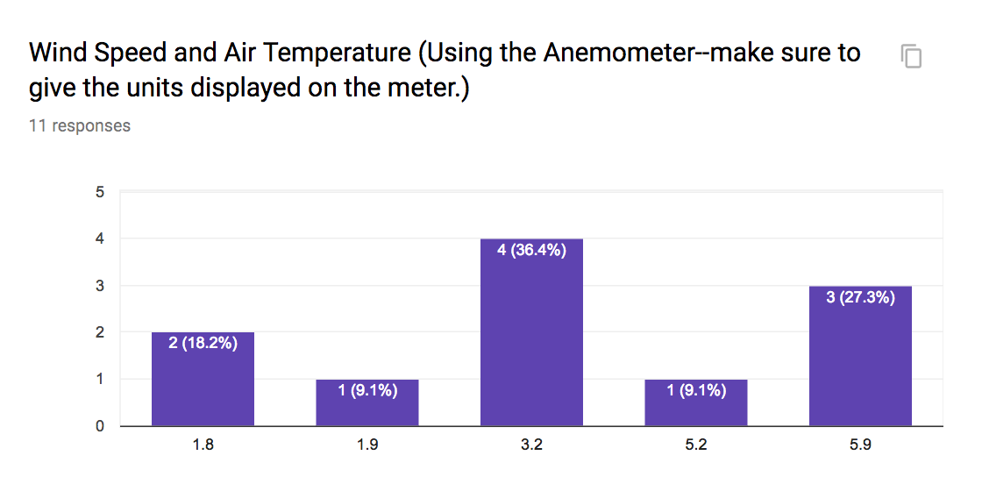
Beaufort Wind Speed – #2 to 3 with windy gusts – | 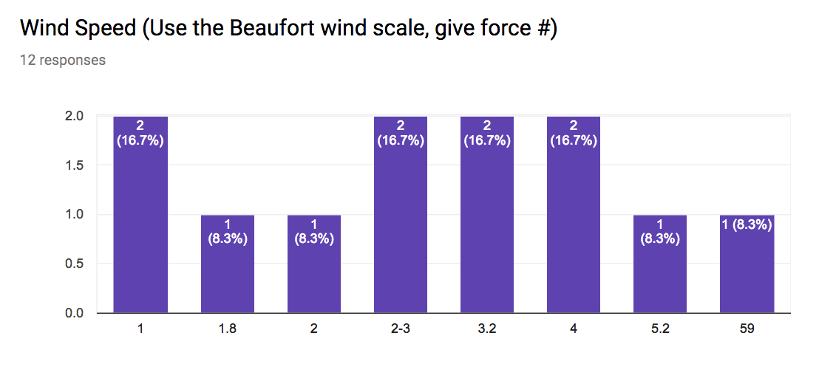
Water Choppy - Fairly choppy with swells and crests at 4-5 ft. | 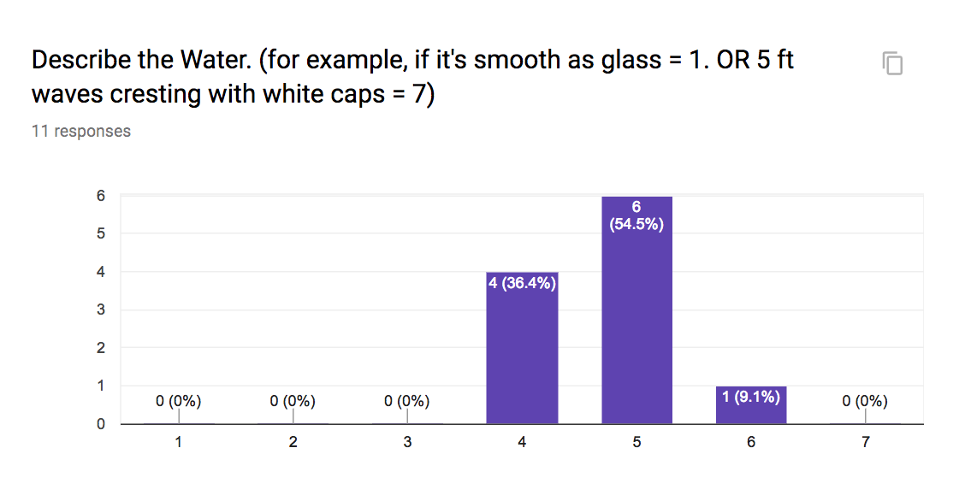
Rain 100% | 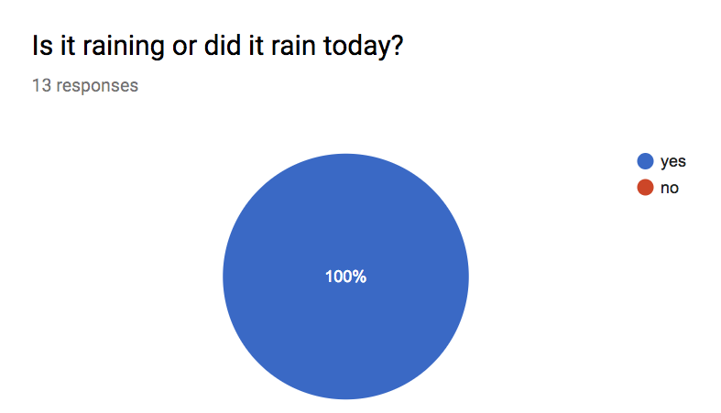
Cloud Cover  Mostly Cloudy/ overcast | 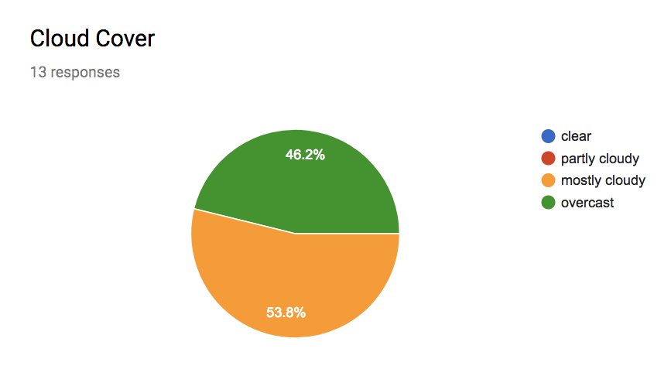
Turbidity  60 CM | 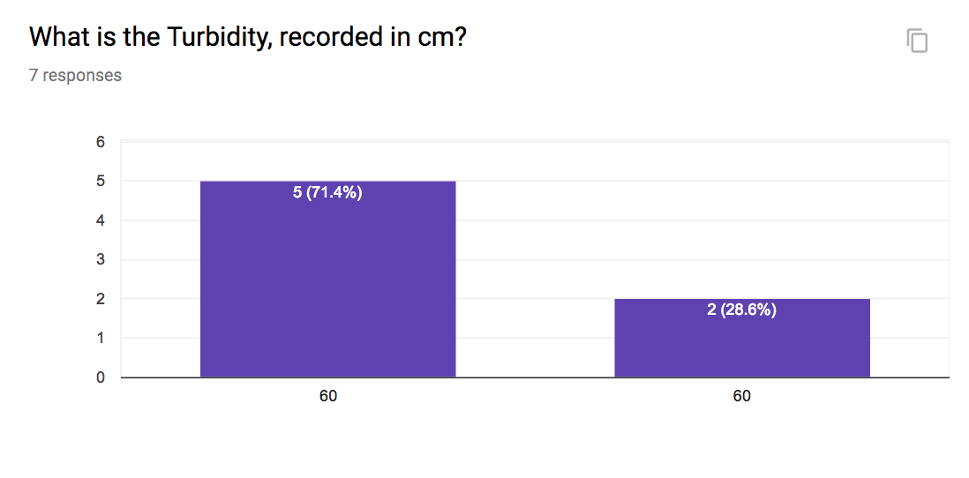
D.O. 5 ppm | 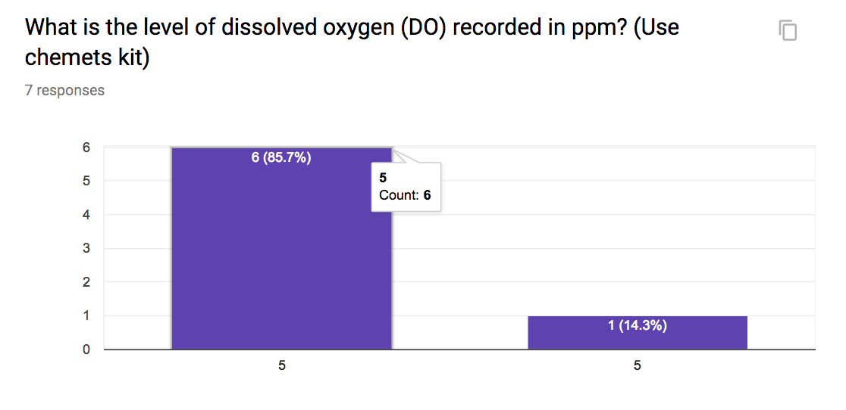
Salinity Hydrometer – Average 24.5 ppt (*without the 44 ppt readings which are not realistic.) | 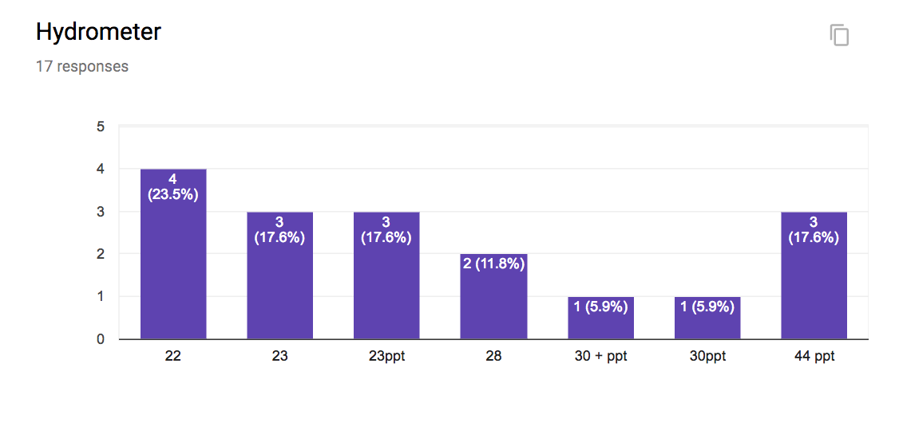
Salinity Refractometer readings are specific gravity – unable to determine  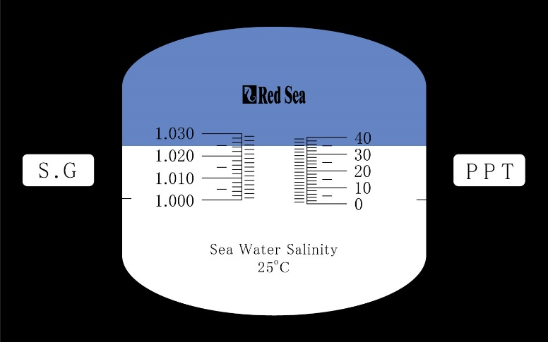 | 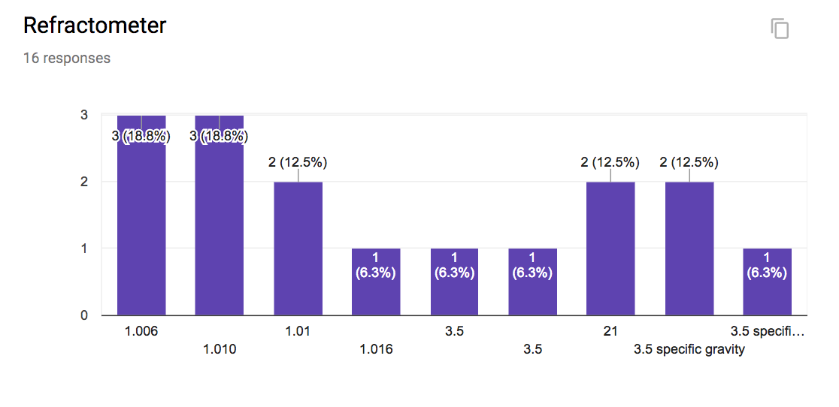
Currents – | 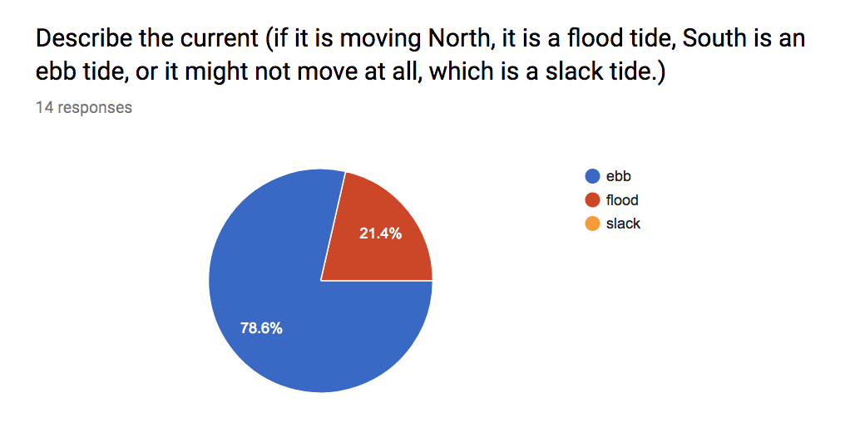
Tide - | 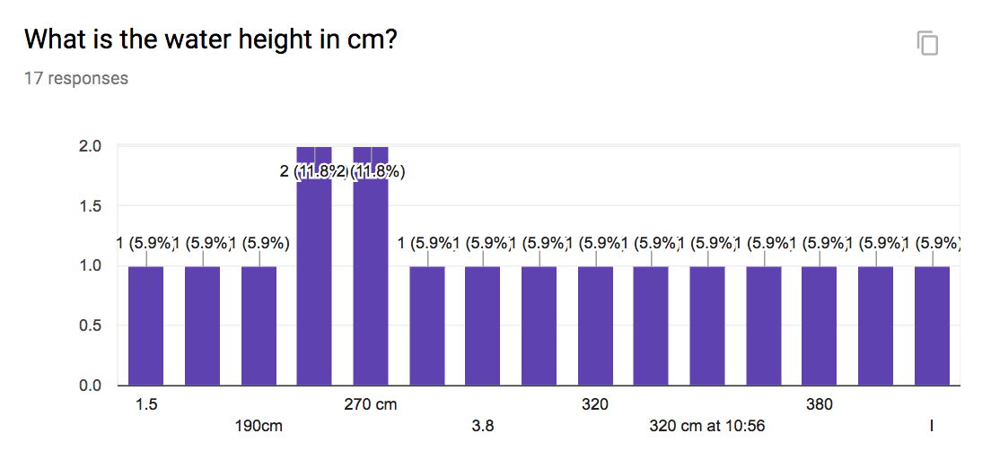
Ship ID | 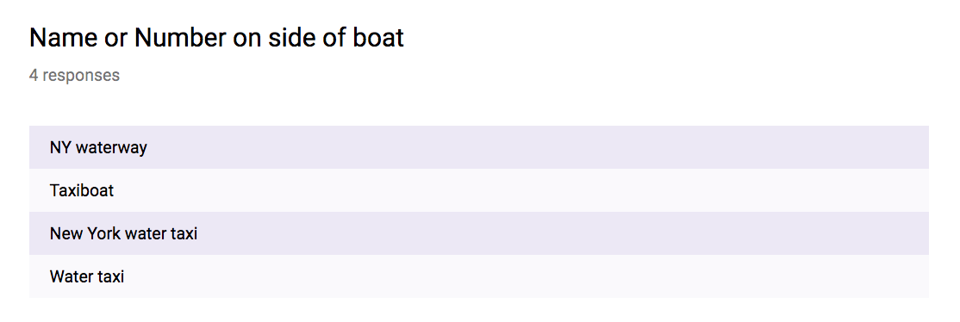

Ship Color | 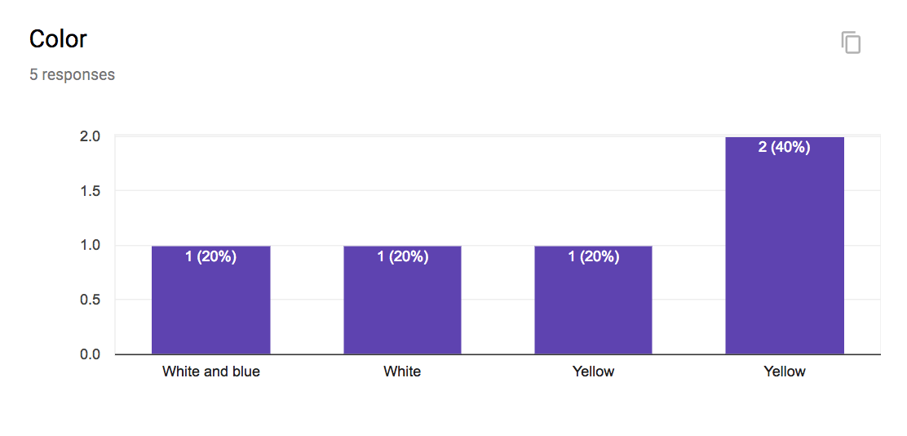

Ship Direction | 